**Spring Core and Maven**

**Exercise 1 - Configuring a Basic Spring Application**

1. **Created a Maven project named LibraryManagement.**
2. **Added Spring Core dependencies in the pom.xml file.**
3. **Created an XML configuration file named applicationContext.xml in the src/main/resources directory.**

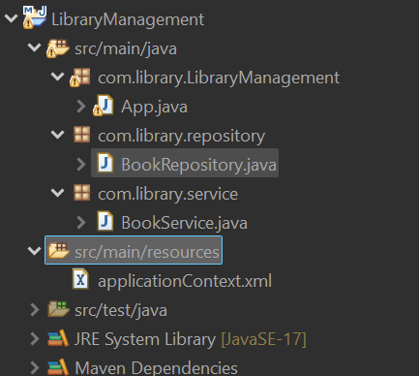

1. **Define beans for BookService and BookRepository in the XML file.**

**Code:**

<?xml version="1.0" encoding="UTF-8"?>

<beans xmlns="http://www.springframework.org/schema/beans"

xmlns:xsi="http://www.w3.org/2001/XMLSchema-instance"

xsi:schemaLocation="https://www.springframework.org/schema/beans

https://www.springframework.org/schema/beans/spring-beans.xsd">

<bean id="bookService" class="com.library.service.BookService"/>

<bean id="bookRepository" class="com.library.repository.BookRepository"/>

</beans>

1. **Created a package com.library.service and add a class BookService.**

**Code:**

package com.library.service;

public class BookService {

public void addBook(String name) {

System.out.println("Book added: " + name);

}

}

1. **Created a package com.library.repository and add a class BookRepository.**

**Code:**

package com.library.repository;

public class BookRepository {

public void saveBook(String bookName) {

System.*out*.println("Book saved to database: " + bookName);

}

}

1. **Created a main class to load the Spring context and test the configuration.**

**Code:**

package com.library.LibraryManagement;

import com.library.service.BookService;

import org.springframework.context.ApplicationContext;

import org.springframework.context.support.ClassPathXmlApplicationContext;

public class Main{

public static void main(String[] args) {

ApplicationContext context = new ClassPathXmlApplicationContext("applicationContext.xml");

BookService service = context.getBean("bookService", BookService.class);

service.addBook("Java Basics");

}

}

**Output:**

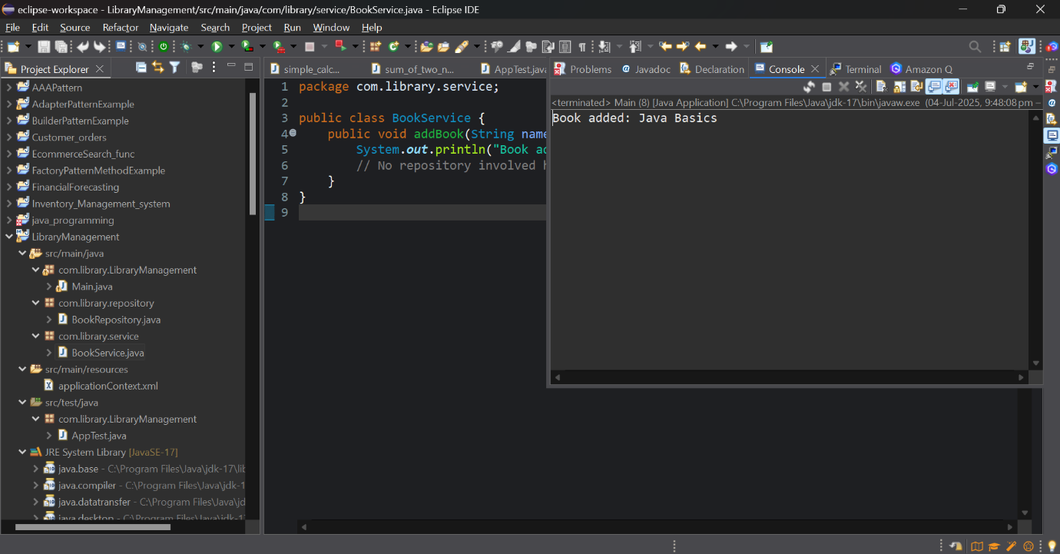

**Exercise 2: Implementing Dependency Injection**

**1. Updated applicationContext.xml to wire BookRepository into BookService.**

**Code:**

<?xml version="1.0" encoding="UTF-8"?>

<beans xmlns="http://www.springframework.org/schema/beans"

xmlns:xsi="http://www.w3.org/2001/XMLSchema-instance"

xsi:schemaLocation="https://www.springframework.org/schema/beans

https://www.springframework.org/schema/beans/spring-beans.xsd">

<bean id="bookRepository" class="com.library.repository.BookRepository"/>

<bean id="bookService" class="com.library.service.BookService">

<property name="bookRepository" ref="bookRepository"/>

</bean>

</beans>

**2. Updated the BookService Class:**

**Code:**

package com.library.service;

import com.library.repository.BookRepository;

public class BookService {

private BookRepository bookRepository;

public void setBookRepository(BookRepository bookRepository) {

this.bookRepository = bookRepository;

}

public void addBook(String bookName) {

System.out.println("Adding book: " + bookName);

bookRepository.saveBook(bookName);

}

}

**3. Ran the LibraryManagementApplication main class to verify the dependency injection.**

**Output:**



